**ASSIGNMENT – 1**

1. **Write a program to print INEURON using pattern programming logic.**

ANS:-

**public** **class** Launch6 {

**public** **static** **void** main(String[] args) {

// **TODO** Auto-generated method stub

**int** i;

**for**(i=0;i<5;i++)

{

System.***out***.print("* ");

}

**for**(i=0;i<5;i++)

{

**if**(i==0 || i==4)

System.***out***.print("* ");

**else**

System.***out***.print(" ");

}

**for**(i=0;i<5;i++)

{

System.***out***.print("* ");

}

**for**(i=0;i<5;i++)

{

**if**(i==0 || i==4)

System.***out***.print("* ");

**else**

System.***out***.print(" ");

}

**for**(i=0;i<5;i++)

{

**if**(i==4)

System.***out***.print(" ");

**else**

System.***out***.print("* ");

}

**for**(i=0;i<5;i++)

{

**if**(i==0 || i==4)

System.***out***.print(" ");

**else**

System.***out***.print("* ");

}

**for**(i=0;i<5;i++)

{

**if**(i==0 || i==4)

System.***out***.print("* ");

**else**

System.***out***.print(" ");

}

System.***out***.println();

**for**(i=0;i<5;i++)

{

**if**(i==2)

System.***out***.print("* ");

**else**

System.***out***.print(" ");

}

**for**(i=0;i<5;i++)

{

**if**(i==2 || i==3)

System.***out***.print(" ");

**else**

System.***out***.print("* ");

}

**for**(i=0;i<5;i++)

{

**if**(i==0)

System.***out***.print("* ");

**else**

System.***out***.print(" ");

}

**for**(i=0;i<5;i++)

{

**if**(i==0 || i==4)

System.***out***.print("* ");

**else**

System.***out***.print(" ");

}

**for**(i=0;i<5;i++)

{

**if**(i==0 || i==4)

System.***out***.print("* ");

**else**

System.***out***.print(" ");

}

**for**(i=0;i<5;i++)

{

**if**(i==0 || i==4)

System.***out***.print("* ");

**else**

System.***out***.print(" ");

}

**for**(i=0;i<5;i++)

{

**if**(i==2 || i==3)

System.***out***.print(" ");

**else**

System.***out***.print("* ");

}

System.***out***.println();

**for**(i=0;i<5;i++)

{

**if**(i==2)

System.***out***.print("* ");

**else**

System.***out***.print(" ");

}

**for**(i=0;i<5;i++)

{

**if**(i==1 || i==3)

System.***out***.print(" ");

**else**

System.***out***.print("* ");

}

**for**(i=0;i<5;i++)

{

System.***out***.print("* ");

}

**for**(i=0;i<5;i++)

{

**if**(i==0 || i==4)

System.***out***.print("* ");

**else**

System.***out***.print(" ");

}

**for**(i=0;i<5;i++)

{

**if**(i==4)

System.***out***.print(" ");

**else**

System.***out***.print("* ");

}

**for**(i=0;i<5;i++)

{

**if**(i==0 || i==4)

System.***out***.print("* ");

**else**

System.***out***.print(" ");

}

**for**(i=0;i<5;i++)

{

**if**(i==1 || i==3)

System.***out***.print(" ");

**else**

System.***out***.print("* ");

}

System.***out***.println();

**for**(i=0;i<5;i++)

{

**if**(i==2)

System.***out***.print("* ");

**else**

System.***out***.print(" ");

}

**for**(i=0;i<5;i++)

{

**if**(i==1 || i==2)

System.***out***.print(" ");

**else**

System.***out***.print("* ");

}

**for**(i=0;i<5;i++)

{

**if**(i==0)

System.***out***.print("* ");

**else**

System.***out***.print(" ");

}

**for**(i=0;i<5;i++)

{

**if**(i==0 || i==4)

System.***out***.print("* ");

**else**

System.***out***.print(" ");

}

**for**(i=0;i<5;i++)

{

**if**(i==0 || i==3)

System.***out***.print("* ");

**else**

System.***out***.print(" ");

}

**for**(i=0;i<5;i++)

{

**if**(i==0 || i==4)

System.***out***.print("* ");

**else**

System.***out***.print(" ");

}

**for**(i=0;i<5;i++)

{

**if**(i==1 || i==2)

System.***out***.print(" ");

**else**

System.***out***.print("* ");

}

System.***out***.println();

**for**(i=0;i<5;i++)

{

System.***out***.print("* ");

}

**for**(i=0;i<5;i++)

{

**if**(i==0 || i==4)

System.***out***.print("* ");

**else**

System.***out***.print(" ");

}

**for**(i=0;i<5;i++)

{

System.***out***.print("* ");

}

**for**(i=0;i<5;i++)

{

**if**(i==0 || i==4)

System.***out***.print(" ");

**else**

System.***out***.print("* ");

}

**for**(i=0;i<5;i++)

{

**if**(i==0 || i==4)

System.***out***.print("* ");

**else**

System.***out***.print(" ");

}

**for**(i=0;i<5;i++)

{

**if**(i==0 || i==4)

System.***out***.print(" ");

**else**

System.***out***.print("* ");

}

**for**(i=0;i<5;i++)

{

**if**(i==0 || i==4)

System.***out***.print("* ");

**else**

System.***out***.print(" ");

}

}

}

1. **Write a program to print**

1111

2222

3333

4444

ANS:-

**public** **class** Launch5 {

**public** **static** **void** main(String[] args) {

// **TODO** Auto-generated method stub

**int** n=4;

**for**(**int** i=1;i<=n;i++)

{

**for**(**int** j=1;j<=n;j++)

{

System.***out***.print(i);

}

System.***out***.println();

}

}

}

1. **WAP to print**

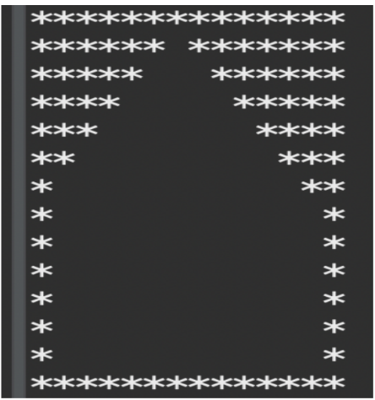

ANS:-

**public** **class** Launch2 {

**public** **static** **void** main(String[] args) {

// **TODO** Auto-generated method stub

**int** n=14;

**for**(**int** i=0;i<n;i++)

{

**for**(**int** j=0;j<n;j++)

{

**if**(i==0 && j<=(n-1)/2 ||

j==0 && i<=(n-1)/2||

i+j<=((n-1)/2)||

j==0 && i<n-1 ||

i==0 && j<n-1 ||

i==n-1 && j<n-1 ||

j==n-1 && i<=n-1 ||

j-i>=(n-1)/2

)

{

System.***out***.print("*");

}

**else**

{

System.***out***.print(" ");

}

}

System.***out***.println();

}

}

}

1. **WAP to print**



ANS:-

**public** **class** Launch3 {

**public** **static** **void** main(String[] args) {

// **TODO** Auto-generated method stub

**int** n=14;

**for**(**int** i=0;i<n;i++)

{

**for**(**int** j=0;j<n;j++)

{

**if**(i==n-1 && j<=n-1 ||

i==n-2 && j<=n-1 ||

i-j>=(n-2)/2 ||

i+j>=(n-1) + (n-1)/2)

{

System.***out***.print("*");

}

**else**

{

System.***out***.print(" ");

}

}

System.***out***.println();

}

}

}

1. **WAP to print**

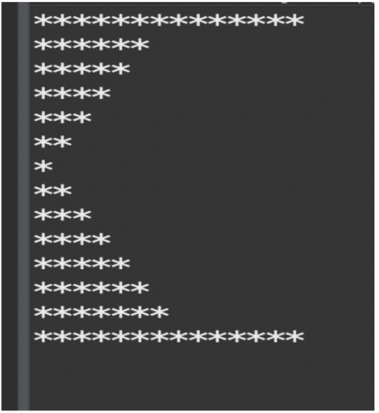

ANS:-

**public** **class** Launch4 {

**public** **static** **void** main(String[] args) {

// **TODO** Auto-generated method stub

**int** n=14;

**for**(**int** i=0;i<n;i++)

{

**for**(**int** j=0;j<n;j++)

{

**if**(i==0 && j<=(n-1)/2 ||

j==0 && i<=(n-1)/2||

i+j<=((n-1)/2) ||

j==0 && i<n-1 ||

i==0 && j<n ||

i==n-1 && j<n||

i-j>=((n-1)/2))

{

System.***out***.print("*");

}

**else**

{

System.***out***.print(" ");

}

}

System.***out***.println();

}

}

}

By,

Yashashwini Grandhe.

Email: yashuxyz2@gmail.com